Son of David Congregation
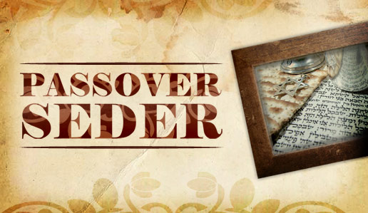
Saturday March 31, 2018
Norbeck Country Club
17200 Cashell Road
Rockville, MD 20853

mandatory pre-registration and payment required
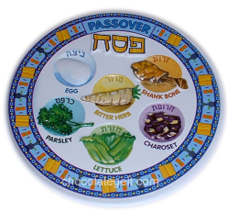
Cost : Adults $ 33.00
Children under 12: $15.00
Children in highchairs: free

Name of Reservation……………………………………………
Phone ……………………………………………………………
Email…………………………………………………………….
No of adults x $33 each = $ …………………………….
No of children x $15.00 each = $ .………………………........
Family maximum x $100 $..............................................
(immediate family only)
Additional donation $ …………………………….
Total amount of payment $ …………………………….
No. of children in highchair (free) …………………………….
Vegetarian option: yes ( ) no ( )

Please deposit this form in the Tzedakah box or mail to the office by
Wednesday, March 21with your payment and label it “Seder”.

Due to catering planning, registration with payment must be received at the office by Wednesday, March 21st.
Forms without payment will be returned.

Son of David Congregation (mailing address)
2815 Norbeck Rd
Silver Spring, MD 20906

